**Artwork**

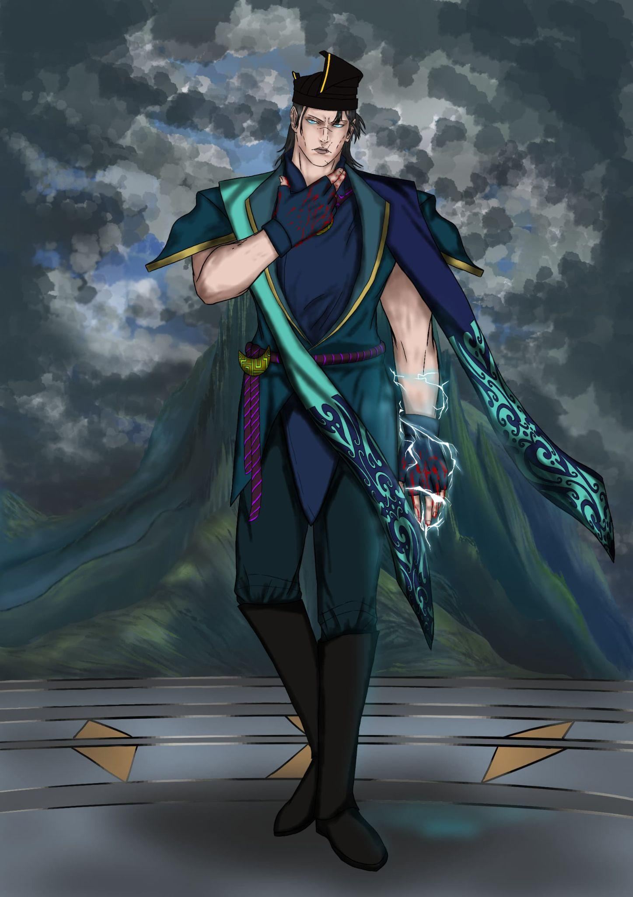 1. Character development - Final concept art Admiral Naga Belau (Sergei Dragunov from Tekken 8)

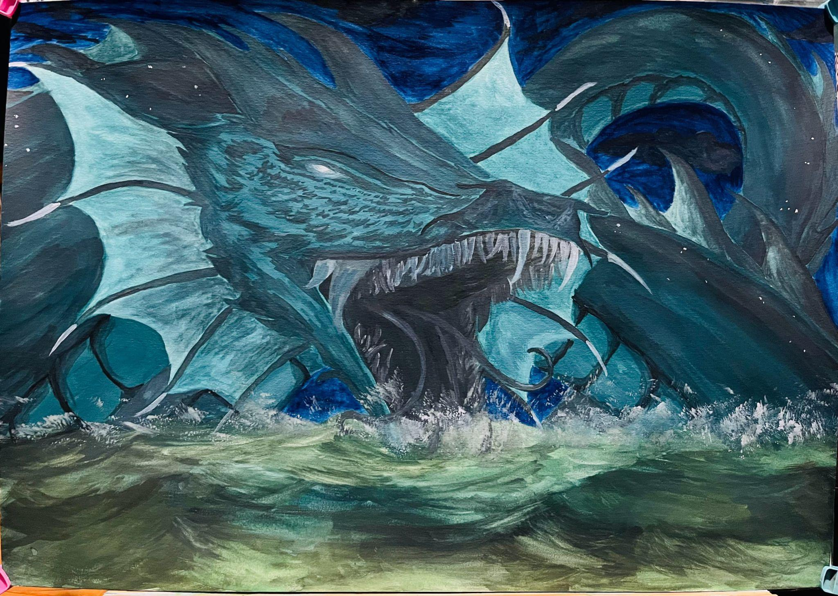 2. Illustration - Dark side of Naga Tambuakar from Sabah Folklore (Traditional art - gouache)

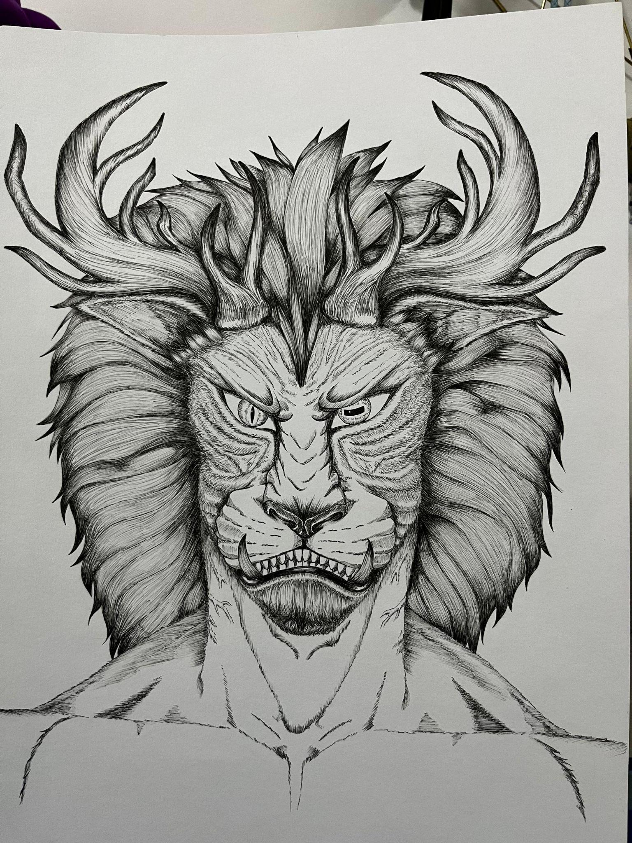 3. Figure design - Mythical creature (Mixed of lion and deer)

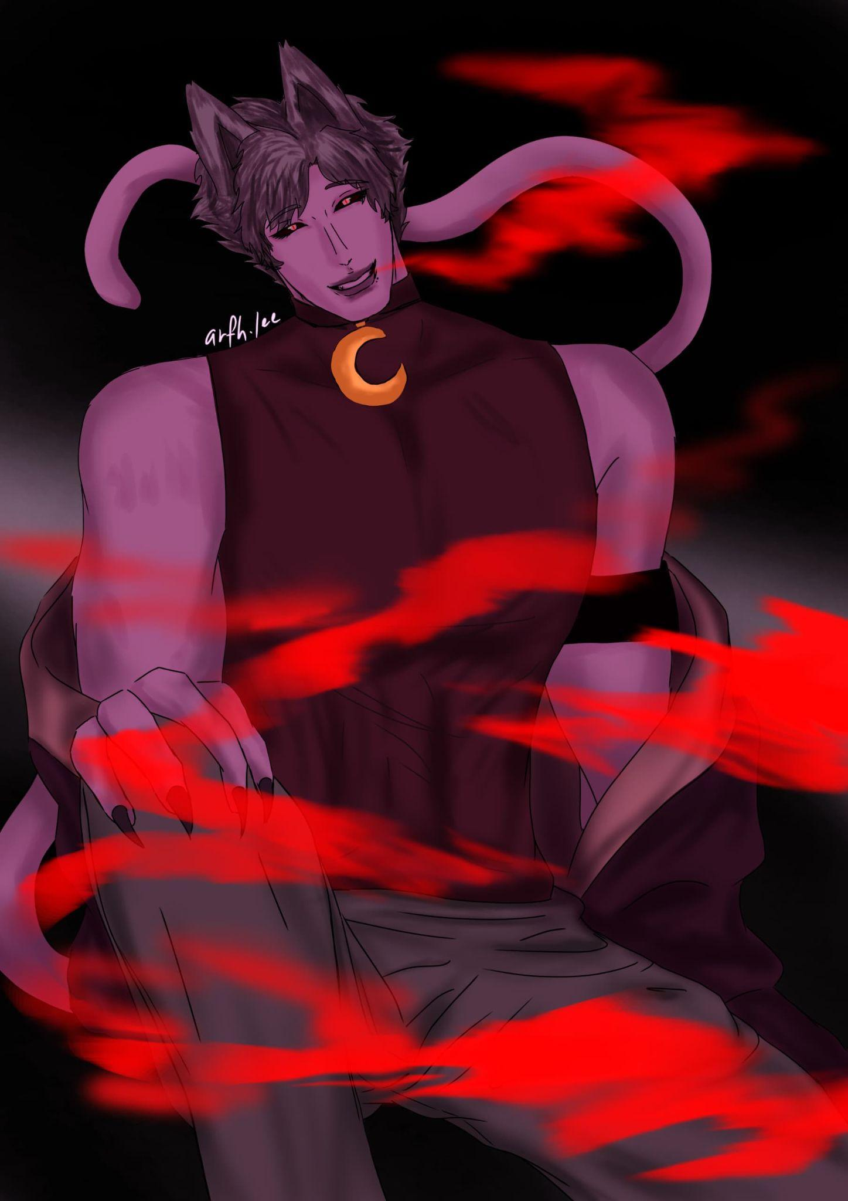 4. Cat nap in human form (From Poppy Playtime)

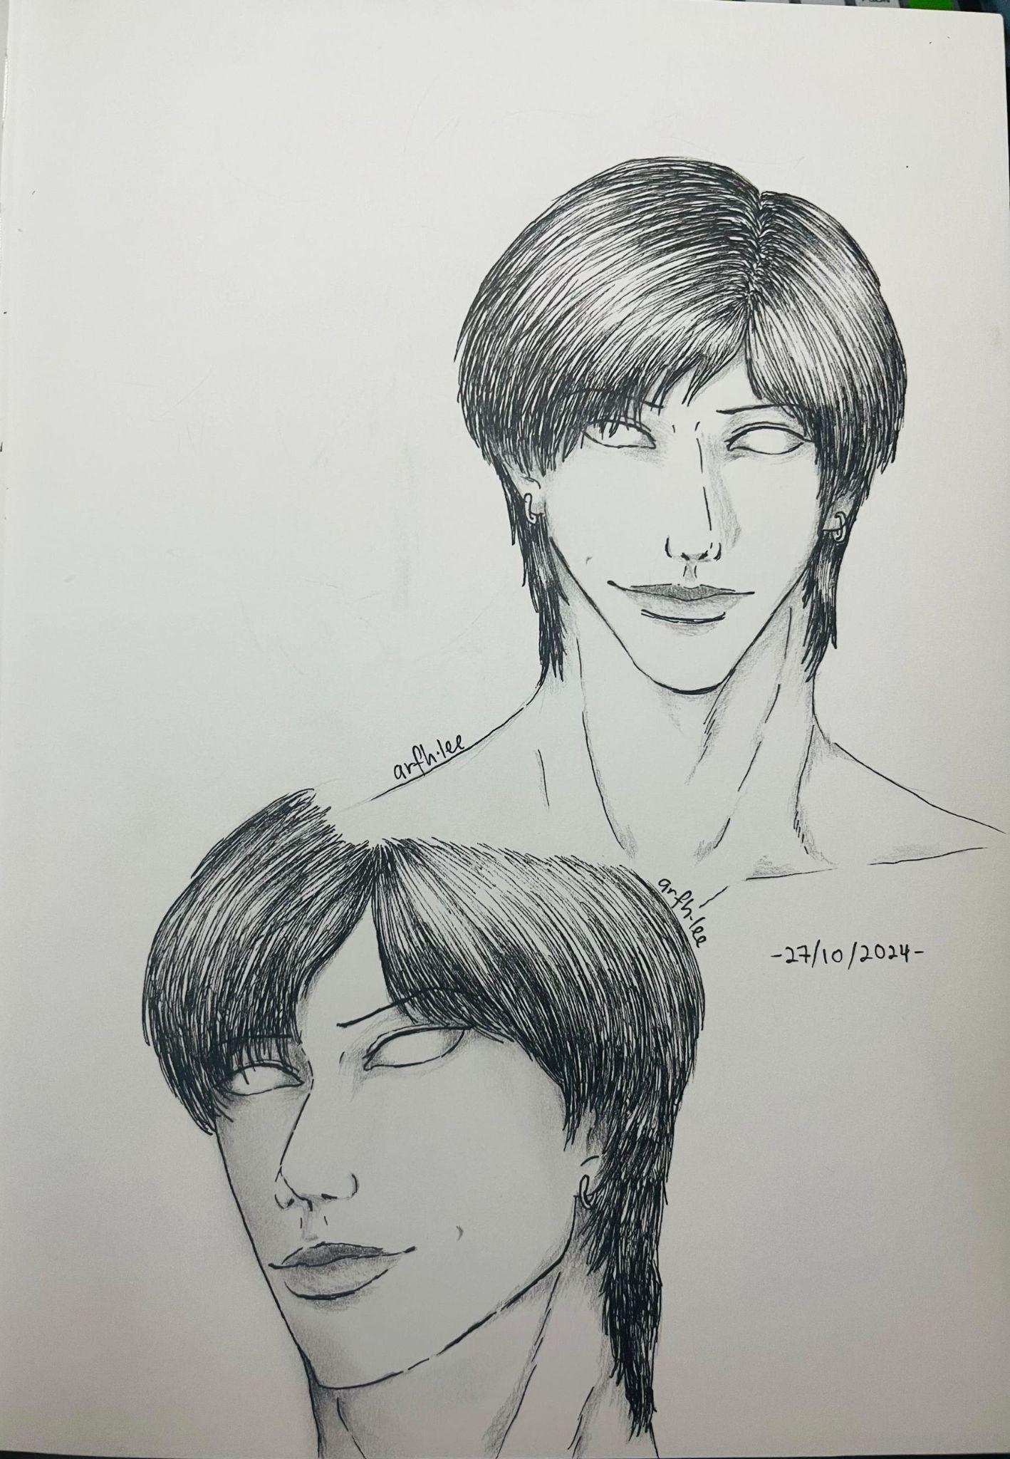 5. Ghost from Manga Lovesickness - Junji Ito Series

**Extras**

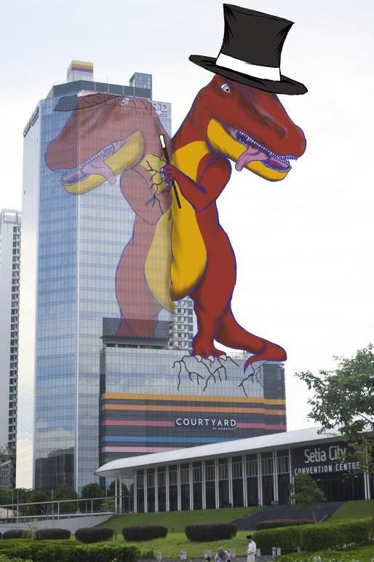 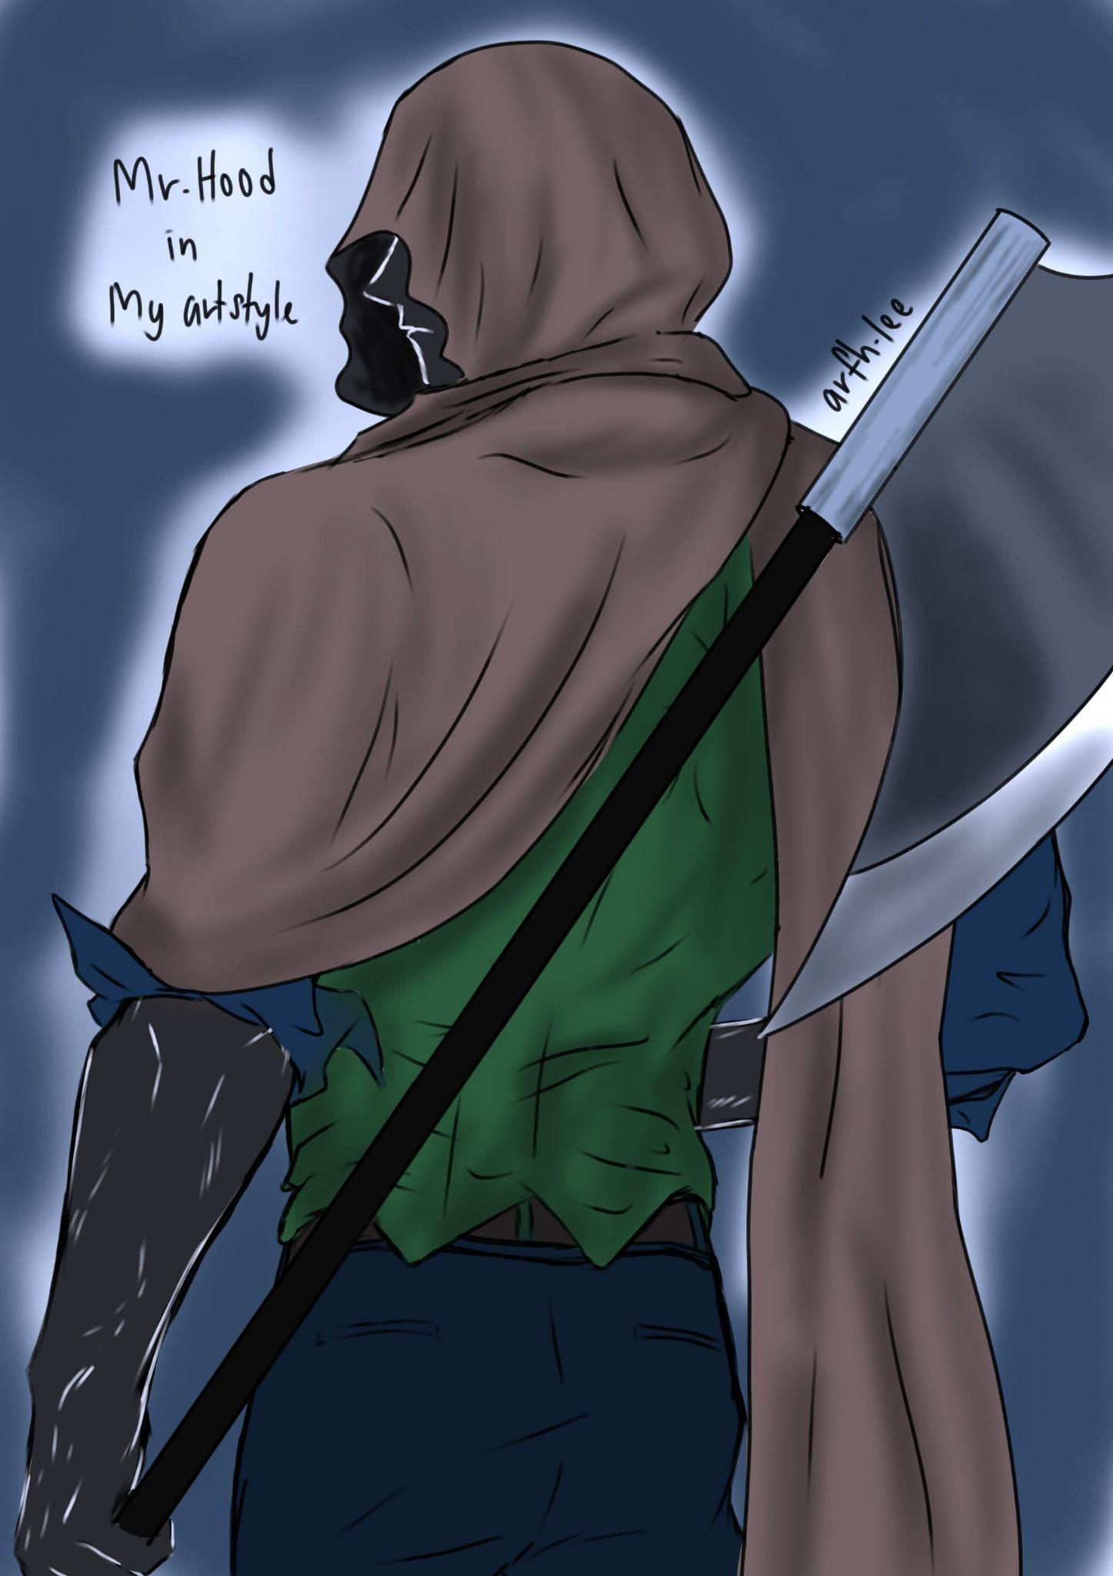

Dino the magician Mr Hood in my artstyle - From Homichiper

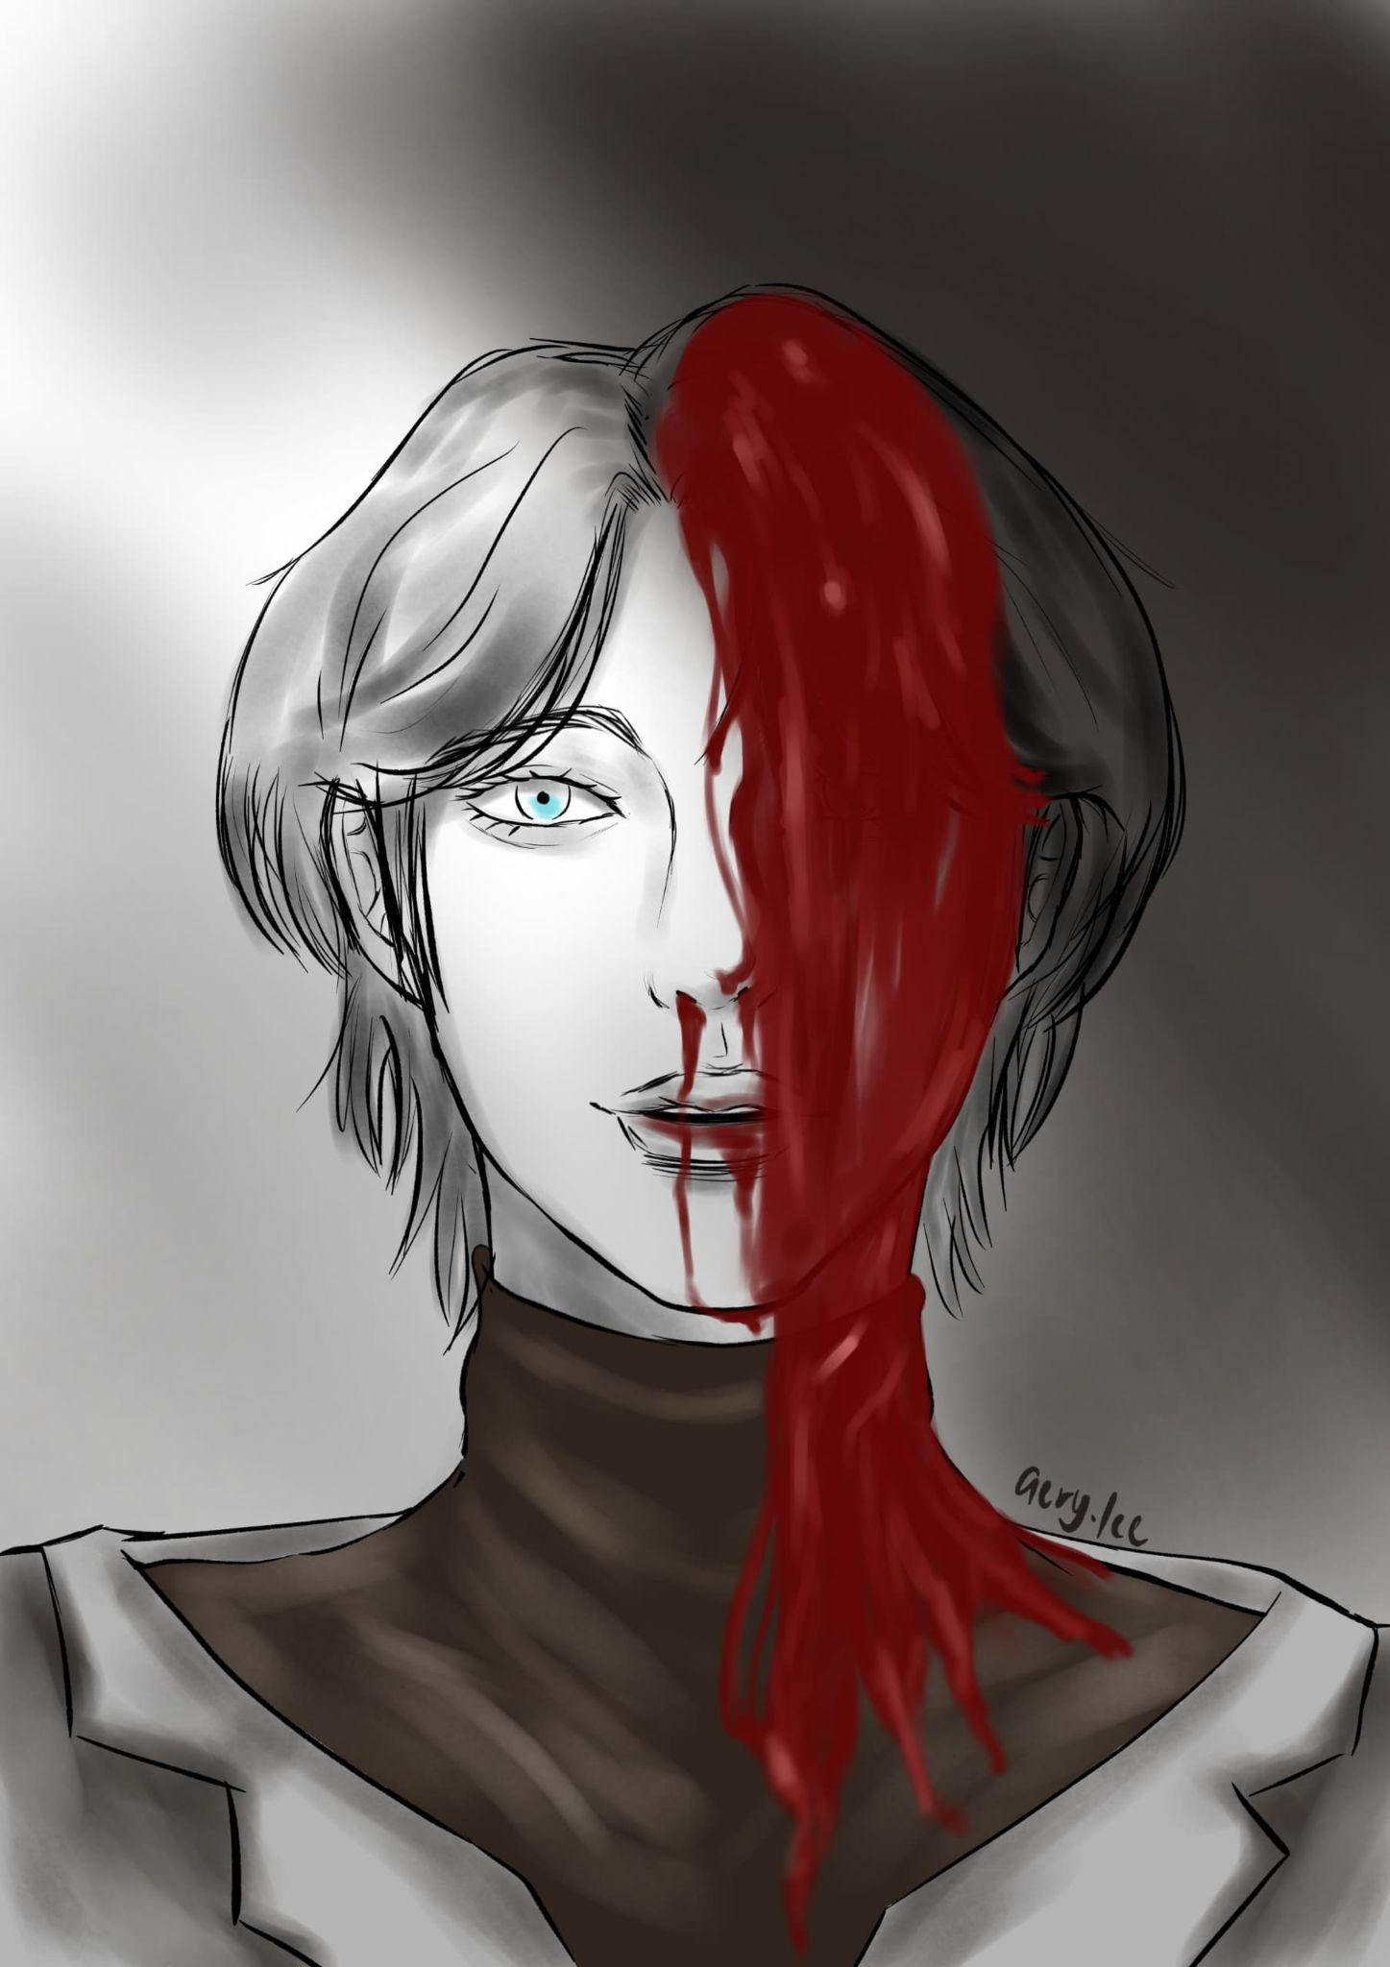

Headache

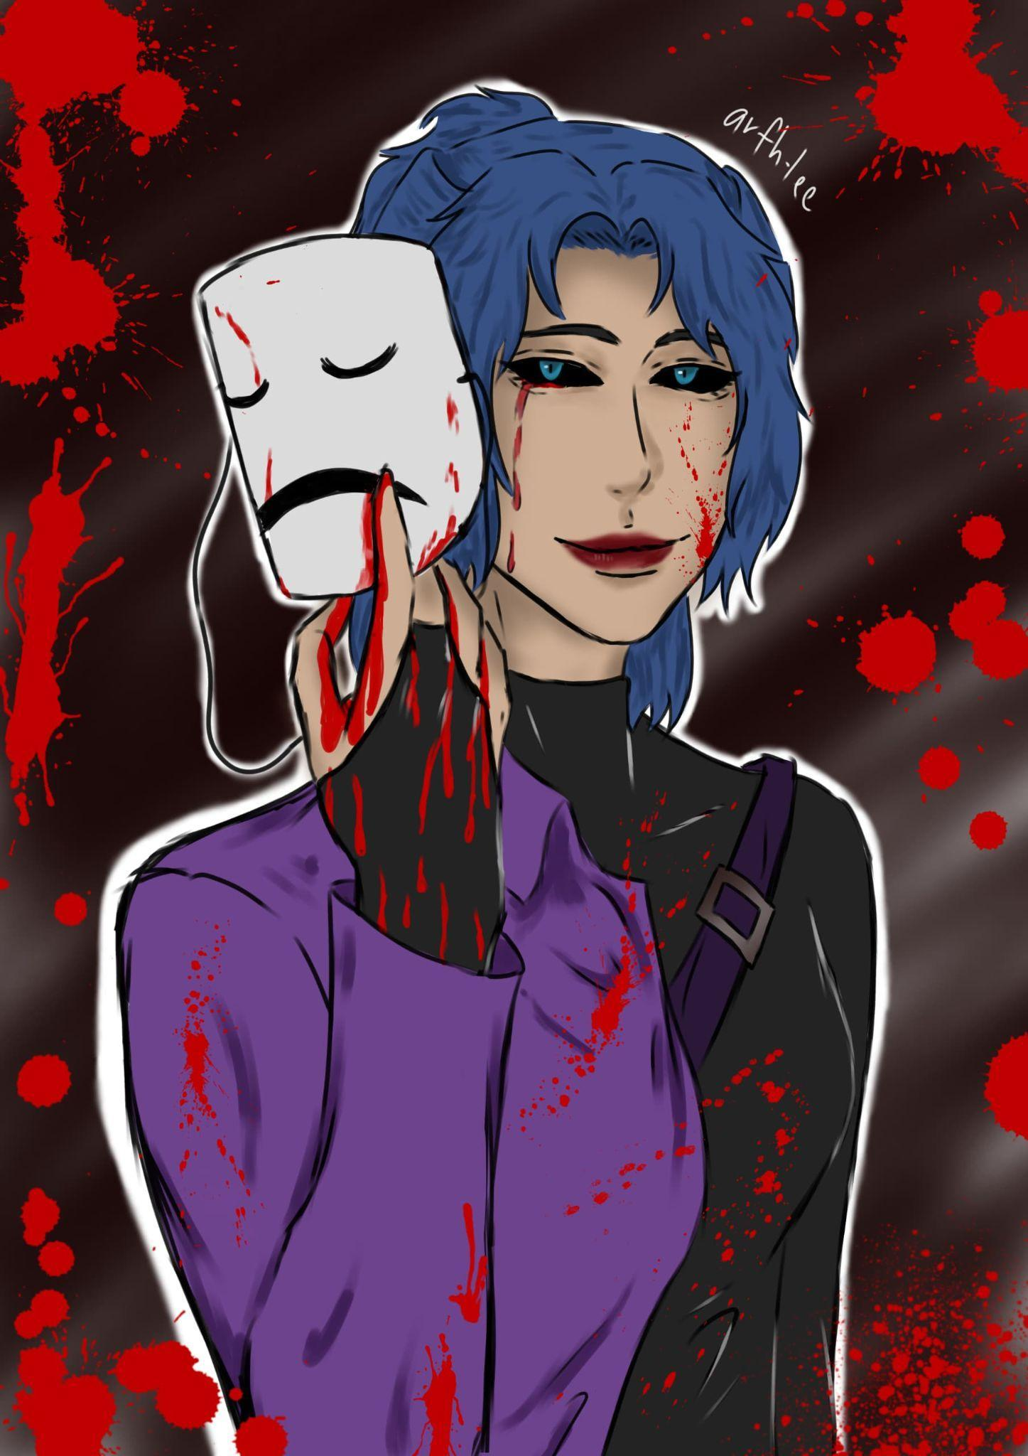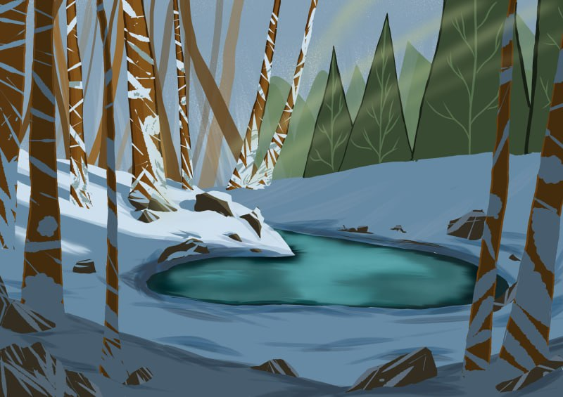

2 side Design Layout- Snowy lake

**Name** : NUR ARIFAH BINTI MOHD ROSLI

**Favorite quotes**

* “The more you read, The more book to read” - Xavier from Love and Deepspace

**Short bio**

* 23 years old. Introverted artists. Always space out when it comes to eating delicious food. Like acrylic and gouache painting too. Sometimes I feels want to draw something, but it takes time when searching for the references (it's a few hours) until the next day I can start to draw. Like buying books and novels but read them later. Addicted to listening to the ambience with smooth jazz music while drawing or doing something else. Tea and Coffee is my favorite drink. Also! I have 3 cats anyway..

**Socmed or email**

* Instagram : @[arfh.lee](http://arfh.ee)
* Email : @nurarifah.roslee@gmail.com